INTERNSHIP PROJECT REPORT
ON
DIABETES HEALTH PREDICTION AND HEALTH MANAGEMENT SYSTEM
Submitted in partial fulfilment of the requirements for the degree of
BACHELOR OF COMPUTER APPLICATIONS (BCA)
under
Shivaji university Kolhapur
Submitted by
NAME :

Roll / Seat No.:

Internal Guide
Prof. R. S. Shinde
External Guide / Organization
IGAP Technology Privet Limited

Academic Year 2026–2027

Certificate from Organization

Declaration by Student
I, [INSERT STUDENT FULL NAME HERE], hereby declare that the internship project report entitled “Diabetes Health Prediction and Health Management System” submitted to Yashwantrao Chavan Warana Mahavidyalaya, Warananagar, affiliated to Shivaji University, Kolhapur, is a record of the project work carried out by me under the guidance of [INSERT GUIDE NAME HERE].
I further declare that this report has been prepared for academic evaluation and that the descriptions of the software, data flow, database and implementation are based on the supplied project source files and repository information. Wherever external technical references have been used, they are acknowledged in the bibliography.
I understand that the system produces a machine-learning-based estimate from entered variables and must not be represented as a medical diagnosis, screening certificate or treatment recommendation. I have not intentionally presented unverified model accuracy values as measured results.
I take responsibility for the originality and accuracy of the final submitted version after filling all highlighted placeholders and verifying institutional details.
- Student Signature: [SIGN HERE]
- Student Name: [INSERT FULL NAME]
- Date: [INSERT DATE]
- Place: [INSERT PLACE]

Acknowledgement
I express my sincere gratitude to [INSERT ORGANIZATION NAME] for providing the opportunity to undertake this internship project and to gain practical exposure to application development, data processing and machine-learning concepts.
I am thankful to [INSERT INDUSTRY SUPERVISOR NAME AND DESIGNATION] for guidance, suggestions and encouragement throughout the project. Their support helped me understand how a software application is planned, implemented, tested and documented.
I extend my appreciation to [INSERT PRINCIPAL NAME], [INSERT HEAD OF DEPARTMENT NAME] and [INSERT INTERNAL GUIDE NAME] of Yashwantrao Chavan Warana Mahavidyalaya, Warananagar, for their academic guidance and support.
I also acknowledge the developers and maintainers of Python, Streamlit, pandas, NumPy, scikit-learn, Plotly, MySQL Connector/Python and other open-source technologies used in this project. Finally, I thank my family, classmates and everyone who contributed suggestions or encouragement.

Abstract
The Diabetes Health Prediction and Health Management System is a web-based application developed using Python and Streamlit. It combines a supervised machine-learning classifier with account management, health assessments, history tracking, family-member records, analytics, reminders and downloadable health-report functionality.
The assessment form accepts age, gender, body mass index (BMI), HbA1c level, blood glucose level, hypertension status, heart-disease status and smoking-history category. The application validates key selections, converts categorical inputs into numeric values in a fixed feature order, invokes a serialized scikit-learn model and calculates the model probability associated with the positive class. The result is displayed as an estimated risk percentage and grouped into lower, elevated or higher presentation bands.
The supplied implementation notebook compares Logistic Regression, Decision Tree, Random Forest and K-Nearest Neighbors using an 80:20 stratified train-test split. It then fits a Random Forest classifier with 100 estimators, a fixed random seed and balanced class weights, and serializes it to model.pkl. The notebook contains code for accuracy, confusion matrix, classification report and ROC-AUC evaluation; no numeric evaluation output was supplied in the notebook source, so this report does not invent performance scores.
The application uses MySQL tables for users, administrators, assessments, family members and reminders. Streamlit provides the interactive interface, pandas and NumPy support data preparation, Plotly supports charts, and Werkzeug provides password hashing and verification. The project illustrates an end-to-end integration of user interface, database operations and machine learning. It is an educational risk-awareness tool only; clinical decisions require qualified healthcare professionals and validated laboratory assessment.

Table of Contents
Chapter 1: INTRODUCTION 10
1.1 Background of Study 10
1.2 Objectives of the Project 11
1.3 Scope of the Project 12
1.4 Need of the Project 13
1.5 Problem Statement 14
1.6 Existing System and Proposed System 15
1.7 Benefits and Constraints 16
Chapter 2: ORGANIZATION PROFILE 17
2.1 Organization Profile – Overview 17
2.2 History and Background of the Organization 18
2.3 Vision and Mission 19
2.4 Products and Services 20
2.5 Organizational Structure 21
2.6 IT Infrastructure 22
2.7 Internship Work Environment and Responsibilities 23
Chapter 3: SYSTEM ANALYSIS AND DESIGN 24
3.1 System Analysis – Introduction 24
3.2 Functional Requirements 25
3.3 Non-functional Requirements 26
3.4 Feasibility Study 27
3.5 System Architecture 28
3.6 Data Flow Diagram – Level 0 29
3.7 Data Flow Diagram – Level 1 30
3.8 UML Use-case Overview 31
3.9 Prediction Workflow and Activity Logic 32
3.10 Database Design – Overview 34
3.11 Entity Relationship Diagram 35
3.12 Data Dictionary – User and Account Tables 36
3.13 Data Dictionary – Assessment and Related Tables 37
3.14 Assessment Feature Dictionary and Encoding 38
3.15 Security, Privacy and Validation Design 39
Chapter 4: SYSTEM DEVELOPMENT AND IMPLEMENTATION 40
4.1 Development Environment 40
4.2 Dataset Preparation 41
4.3 Exploratory Data Review and Feature Selection 42
4.4 Model Selection and Training 43
4.5 Random Forest Model – Concept 44
4.6 Model Evaluation Methodology 45
4.7 Model Serialization and Loading 46
4.8 Model Integration with Streamlit 47
4.9 Module 1 – User Registration and Login 48
4.10 Module 2 – User Profile 49
4.11 Module 3 – Diabetes Assessment 50
4.12 Module 4 – Family Member Management 51
4.13 Module 5 – History, Analytics and Progress 52
4.14 Module 6 – Reminders and Health Knowledge 53
4.15 Module 7 – Health Reports and Administrator Dashboard 54
4.16 Database Connectivity and SQL Operations 55
4.17 User Interface Design and Navigation 56
4.18 Screens of the Application 57
4.19 Implementation and Deployment Process 64
4.20 Coding Evidence and Important Source Files 65
4.21 Implementation Review and Improvement Opportunities 66
Chapter 5: OUTPUT AND RESULTS 67
5.1 Testing Strategy 67
5.2 Functional Test Cases – Authentication and Profile 68
5.3 Functional Test Cases – Assessment 69
5.4 Functional Test Cases – History, Analytics and Reports 70
5.5 Results Obtained – Functional Results 71
5.6 Model Results and Performance Evidence 72
5.7 System Performance Considerations 73
5.8 User Feedback and Usability Evaluation 74
5.9 Limitations of the Current System 75
5.10 Future Scope 76
Chapter 6: CONCLUSION AND SUGGESTIONS 77
6.1 Summary of the Project 77
6.2 Objectives Achieved 78
6.3 Learning Outcomes 79
6.4 Suggestions and Recommendations 80
6.5 Conclusion 81
Bibliography and References 82
Annexure A – Project File Inventory 83
Annexure B – Database Table Summary 84
Annexure C – Input and Output Specification 85
Annexure D – Student Completion Checklist 86

LIST OF FIGURES
Figure 3.1: System architecture of the Diabetes Health Prediction System 28
Figure 3.2: Level 0 data flow diagram 29
Figure 3.3: Level 1 data flow diagram 30
Figure 3.4: Use-case overview 31
Figure 3.5: Entity relationship diagram 35
Figure 4.1: Home page of the Diabetes Health Prediction application 57
Figure 4.2: User registration page 57
Figure 4.3: User login page 57
Figure 4.4: User dashboard 58
Figure 4.5: Diabetes assessment input form 58
Figure 4.6: Diabetes prediction result 59
Figure 4.7: My Assessment / assessment history page 59
Figure 4.8: Family members assessment page 60
Figure 4.9: Family member assessment history 60
Figure 4.10: Analytics dashboard 61
Figure 4.11: Progress tracking page 61
Figure 4.12: Reminders page 62
Figure 4.13: Health knowledge page 62
Figure 4.14: Reports page 63
Figure 4.15: User profile page 63
Figure 4.16: Administrator login and dashboard 64

LIST OF TABLES
Table 1.1: Project objectives 11
Table 1.2: Scope boundaries 12
Table 2.1: Organization profile details 17
Table 2.2: Summary of internship activities 23
Table 3.1: Functional requirements 25
Table 3.2: Non-functional requirements 26
Table 3.3: Feasibility assessment 27
Table 3.4: Database tables and purpose 34
Table 3.5: Assessment feature dictionary and input encoding 38
Table 4.1: Tools and technologies used 40
Table 4.2: Model evaluation metrics 45
Table 4.3: Application modules 48
Table 5.1: Functional test cases 68
Table 5.2: Observed model results and evidence limitations 72
Table 6.1: Learning outcomes 79

1.1 Background of Study
Diabetes is a long-term metabolic condition associated with elevated blood glucose. Risk is influenced by several factors, including age, body composition, family and medical history, lifestyle and glycaemic measurements. Awareness and timely consultation can support prevention and management, but identifying a person's clinical status requires appropriate medical evaluation.
Digital health applications can make selected health information easier to record, review and communicate. Machine learning offers methods for identifying statistical patterns in historical datasets and applying a trained model to new input records. In a supervised classification task, examples are associated with known labels and an algorithm learns a mapping between input features and the target class.
This project applies that general approach to a diabetes-risk prediction use case. A user enters a limited set of health attributes into a Streamlit form. The application converts these values into the numeric representation expected by a trained Random Forest classifier. The model returns a class prediction and class probabilities, which the interface presents as an estimated risk percentage.
The project extends beyond a single prediction form. It includes account registration and login, user profiles, personal assessment history, family-member assessments, analytics, progress views, reminders and health reports. These functions demonstrate how an ML component can be embedded in a broader information system with persistent storage.

1.2 Objectives of the Project
The primary objective is to develop a web-based system that demonstrates how a supervised machine-learning model can be integrated with a health-information interface. The system is designed to accept structured input, produce an estimated diabetes-risk output and retain assessment records for later review.
The project also aims to provide a user account workflow so that assessment data can be associated with a registered account. A family-member feature enables a user to maintain separate assessment subjects under the same account. Historical records and visual analytics are intended to make changes in entered measurements and prediction outputs easier to review over time.
From a software-engineering perspective, the project aims to demonstrate modular Python code, database integration, input validation, password hashing, chart generation and deployment of an interactive application. The project also provides a practical setting for learning data preparation, train-test splitting, model comparison and model serialization.
- Build an interactive Streamlit application for diabetes-risk estimation.
- Use a trained Random Forest classifier loaded from model.pkl.
- Capture age, gender, BMI, HbA1c, blood glucose, hypertension, heart disease and smoking history.
- Store user, family-member, assessment and reminder records in MySQL.
- Provide assessment history, analytics, progress, reminders and health-report features.
- Apply basic authentication, validation and password-hashing practices.

1.3 Scope of the Project
The project scope covers a browser-based application that accepts a defined set of user-entered variables and generates a model-based classification and probability. The user can create an account, log in, maintain profile information, perform a personal assessment, add family members and review stored assessment information. The application also contains administrative views and several information-management pages.
The technical scope includes Python application logic, Streamlit interface components, pandas and NumPy data handling, a pre-trained scikit-learn model, MySQL persistence and Plotly visualizations. The supplied SQL file defines five principal tables: admins, users, assessments, family_members and reminders. The application reads database credentials from Streamlit secrets in a hosted environment and uses a local MySQL configuration for development.
The project does not provide clinical diagnosis, treatment selection, medication dosing or emergency triage. The model output is dependent on the training dataset, feature definitions and preprocessing assumptions. It should not be used as a replacement for laboratory tests, a physician's assessment or established clinical risk tools. External validation, calibration, fairness evaluation and clinical governance are outside the demonstrated implementation.
- Included: risk estimate from eight input variables; account/profile functions; personal and family assessment records; dashboards and analytics; reminders; health reports; administrator dashboard.
- Excluded: diagnosis, treatment prescription, integration with hospital electronic health records, continuous glucose monitoring, medical-device control and clinician-approved clinical decision support.

1.4 Need of the Project
Health information is often recorded across paper notes, laboratory documents and personal applications. A simple digital interface can help users enter a consistent set of variables and retain a history of their assessments. This project explores how an interactive application can make a basic predictive workflow accessible through a web browser without requiring users to run a notebook or write code.
The project is also useful as an academic integration exercise. It combines concepts that are often taught separately: front-end interaction, Python programming, database management, data preprocessing, classification, model persistence and visualization. Implementing these components together gives the student experience in handling data from form submission through prediction and storage.
Another need addressed is the ability to associate records with more than one person. The family-member module stores named subjects under a user account and associates assessment rows with the relevant member identifier. This allows the application to organize personal and family assessment histories without creating a separate login for each family member.

1.5 Problem Statement
The project addresses the problem of providing a convenient digital workflow for entering selected diabetes-related health attributes, obtaining a model-generated risk estimate and retaining the result for future reference. A notebook-only model is difficult for non-technical users to operate, while a one-time calculator does not provide account-based history or family-member tracking.
The proposed system wraps a serialized classification model in a Streamlit application and connects the workflow to a relational database. It seeks to improve accessibility and record organization while keeping the prediction process understandable. The core technical challenge is to ensure that the values submitted by the form are encoded in exactly the same feature order and representation used during model training.
The system must also manage user identity, protect stored credentials, associate records with the correct account and handle database or prediction errors. Because the use case relates to health, the application must communicate the limits of automated estimates and avoid presenting its output as a medical conclusion.

1.6 Existing System and Proposed System
In a manual process, a person may review measurements independently, maintain notes or consult a healthcare provider. A data-science prototype may train a classifier in a notebook but may not provide a complete interface, user accounts or persistent history. These approaches can be appropriate for their intended purposes but do not combine all the functions demonstrated in this project.
The proposed system provides a browser-based interface with an integrated prediction workflow. It uses Streamlit to capture information, Python to validate and encode the inputs, scikit-learn to produce a prediction and MySQL to store assessment records. Additional pages provide personal and family histories, charts, reminders and reports.
The proposed system is not necessarily more clinically accurate than a manual or professional process. Its contribution is a software workflow and educational demonstration. Any comparison of predictive quality would require a reproducible evaluation dataset, metrics, external validation and a clinically appropriate baseline.
Aspect | Manual / prototype workflow | Proposed application
Input | Paper or notebook values | Structured Streamlit form
Prediction | Manual review or notebook execution | Serialized Random Forest model
History | Separate notes or files | MySQL assessment records
Family tracking | Separate records | Family-member association
Visualization | Manual charts | Plotly analytics pages

1.7 Benefits and Constraints
The application provides a single place to capture a set of attributes, run the configured model and review saved assessment records. It demonstrates the value of integrating prediction with data management rather than treating the classifier as an isolated script. The dashboard and analytics pages can support exploration of stored records, while reminders provide a simple mechanism for recording health-related tasks.
Important constraints remain. The model depends on the dataset used for training and may not generalize to all populations or clinical settings. Input values are manually entered and can be inaccurate. The application does not demonstrate an external clinical validation study, calibrated probability assessment or a formal privacy/security audit. The hosted service may also depend on external database availability and correct secrets configuration.
Accordingly, the system should be presented as an academic prototype. Before any real-world deployment involving personal health information, the project would require stronger access controls, encryption in transit and at rest, secure secret management, audit logging, backup procedures, consent and retention policies, accessibility testing and review by qualified healthcare and data-protection professionals.

2.1 Organization Profile – Overview
The supplied repository and application identify the software as “Diabetes Prediction and Health Management System” and display the product name “Diabetes Health”. The repository is publicly hosted on GitHub under the account sakshianilGharge, and the associated Streamlit application is published at the project URL supplied for this report.
No formal company profile, registered organization name, address, incorporation date, employee list or official mission statement was included in the uploaded source archive. Therefore, this chapter distinguishes verified project and platform information from organization-specific information that must be completed by the student or internship provider.
For academic submission, the organization profile should describe the actual internship host rather than treating GitHub or Streamlit as the employer. The highlighted fields below are intentionally left for completion using an official company brochure, website, internship letter or supervisor confirmation.
- Organization Name: [INSERT OFFICIAL ORGANIZATION NAME]
- Address: [INSERT REGISTERED / OFFICE ADDRESS]
- Website: [INSERT OFFICIAL WEBSITE]
- Internship Department: [INSERT DEPARTMENT]
- Internship Duration: [INSERT DATES]

2.2 History and Background of the Organization
[INSERT ORGANIZATION NAME] was established in [INSERT YEAR] with the objective of [INSERT VERIFIED ORGANIZATIONAL PURPOSE]. Its early activities included [INSERT VERIFIED HISTORY], and the organization has since developed its work in [INSERT VERIFIED INDUSTRY OR SERVICE AREAS].
The project repository itself documents a software solution focused on diabetes prediction and health management. The public GitHub repository describes the project as a “Diabetes Prediction and Health Management System” and exposes the principal application source, model artifact, dataset and dependency list. The repository is a project artifact and should not be mistaken for proof of the host organization's corporate history.
Students should replace the bracketed text with verified details from the internship organization. If the internship was completed under an academic department or individual mentor rather than a company, describe that arrangement accurately and obtain approval from the project guide.

2.3 Vision and Mission
Official vision and mission statements for the internship organization were not present in the uploaded project files. The following wording is therefore a suggested placeholder framework only and must be replaced with the organization's approved statements before submission.
Vision: [INSERT THE ORGANIZATION'S OFFICIAL VISION STATEMENT]. Mission: [INSERT THE ORGANIZATION'S OFFICIAL MISSION STATEMENT]. Core values: [INSERT VERIFIED VALUES SUCH AS INTEGRITY, INNOVATION, CUSTOMER SERVICE OR SOCIAL RESPONSIBILITY ONLY IF CONFIRMED].
In relation to the software project, its design intent is to demonstrate accessible health-risk awareness and structured record management. This project-level intent is not an official organizational mission and should be labelled separately if retained in the final report.

2.4 Products and Services
The official products and services of [INSERT ORGANIZATION NAME] should be described using verified information supplied by the host. Examples may include software development, IT consulting, data services, training or other business activities, but only those actually offered by the organization should be included.
The project artifact developed or studied during the internship is a web-based diabetes health prediction and management application. Its visible functions include user registration and login, profile management, risk assessment, personal assessment history, family-member management, analytics, progress tracking, reminders, health knowledge and health reports. The application also contains administrator login and an administrative dashboard.
These functions are features of the submitted project, not necessarily commercial services offered by the internship organization. The student should keep this distinction clear to avoid making unsupported claims about the host.
- Organization products/services: [INSERT VERIFIED LIST]
- Project deliverable: Diabetes Health Prediction and Health Management System
- Project delivery mode: Browser-based Streamlit application with MySQL persistence and a serialized ML model.

2.5 Organizational Structure
The formal organizational structure of the internship host was not supplied. Insert the approved reporting structure, including the managing head, technical department, project supervisor and the student's reporting contact. A simple structure may be represented as a hierarchy only when it reflects the actual organization.
For this project, the practical development responsibilities can be described independently of the host's official hierarchy. The student/developer analyses requirements, prepares data, trains and serializes the model, develops Streamlit pages, connects the database, tests workflows and prepares documentation. The project guide or industry supervisor reviews progress and provides feedback.
Suggested organizational chart fields: [INSERT ORGANIZATION HEAD]; [INSERT DEPARTMENT HEAD]; [INSERT TECHNICAL / PROJECT SUPERVISOR]; [INSERT INTERN / STUDENT NAME]. Obtain approval before presenting this as the official organization chart.

2.6 IT Infrastructure
The project source indicates a Python-based development stack. The user interface is implemented with Streamlit. Data manipulation uses pandas and NumPy. The model is loaded through Python pickle and was trained using scikit-learn. Plotly is imported for interactive charts, Pillow supports image handling, Werkzeug provides password-hash utilities, and mysql-connector-python connects the application to MySQL.
The database module supports two connection configurations. In a hosted environment it reads the MySQL host, port, username, password and database from Streamlit secrets. For local development it connects to a MySQL service on localhost using the database name diabetes_health. The supplied SQL dump identifies MariaDB 10.4.32 as the export environment, which is compatible with common MySQL workflows but should be distinguished from a verified production database version.
The source archive includes a Streamlit configuration directory, logo assets, the dataset, model artifact, SQL schema, application scripts and an implementation notebook. The exact hosting hardware, CPU, memory, network capacity, production database instance and monitoring setup were not verifiable from the archive.

2.7 Internship Work Environment and Responsibilities
The internship work associated with this project can be described as a sequence of software-development activities: understanding the problem, reviewing the dataset, preparing features, training candidate classifiers, selecting and serializing a model, designing the application workflow, implementing database-backed features, testing and documenting the result.
Typical responsibilities include reading and understanding existing code, identifying required input fields, maintaining consistent feature order, writing SQL queries, handling form validation, managing application state, displaying charts and creating user-facing result messages. The developer must also verify that stored records are associated with the authenticated account and that errors are handled without leaving database connections open.
Add the actual weekly or phase-wise internship log here. The dates and activities must match the internship diary or supervisor record: [INSERT WEEK / DATE / TASK / OUTCOME TABLE].
Period | Work carried out | Evidence / output
Week 1 | [INSERT ACTUAL TASKS] | [INSERT EVIDENCE]
Week 2 | [INSERT ACTUAL TASKS] | [INSERT EVIDENCE]
Week 3 | [INSERT ACTUAL TASKS] | [INSERT EVIDENCE]
Week 4 | [INSERT ACTUAL TASKS] | [INSERT EVIDENCE]

3.1 System Analysis – Introduction
System analysis identifies what the application must do, the information it must manage and the constraints within which it operates. The analysis is based on the supplied Streamlit source, database helper, SQL dump, model-training notebook and requirements file. It is therefore a source-based description of the implementation rather than a claim that a separate formal requirements workshop was conducted.
The main system actors are a registered user and an administrator. A registered user can access personal assessment functions and associated records. The administrator interface provides aggregate and record-oriented views. The system's main processing components are the Streamlit interface, Python application logic, serialized Random Forest model and MySQL database.
The central transaction begins when a user enters health details and submits the assessment form. The application validates required text and gender selection, resolves whether the subject is the logged-in user or a family member, encodes categorical fields, invokes the model, computes the positive-class probability and inserts an assessment row into the database.

3.2 Functional Requirements
Functional requirements describe services that the system is expected to provide. The source implements several distinct workflows rather than a single prediction screen. These requirements are derived from the page functions and database operations present in the supplied application.
Registration and login workflows manage user access. Profile functions allow personal information and account information to be displayed or updated. The assessment workflow accepts health variables and produces an estimated risk output. The family workflow creates and selects family-member records, and historical views retrieve previous assessments.
Additional functional areas include personal and family analytics, dataset analytics, progress charts, reminders, health knowledge, health reports and administrative dashboards. Some pages depend on stored data being available and on the configured database connection.
ID | Requirement | Priority
FR-01 | Allow a user to register and log in | High
FR-02 | Validate assessment form fields | High
FR-03 | Encode inputs and run the trained model | High
FR-04 | Display class and estimated risk percentage | High
FR-05 | Save assessment details in MySQL | High
FR-06 | Associate assessments with family members | Medium
FR-07 | Display personal/family history and analytics | Medium
FR-08 | Create and manage reminders | Medium
FR-09 | Provide health reports and knowledge pages | Medium
FR-10 | Provide administrator views | Medium

3.3 Non-functional Requirements
Non-functional requirements concern qualities such as usability, reliability, security, maintainability and performance. The application uses Streamlit's standard browser interface and a dark custom theme. Its pages are arranged around a sidebar navigation pattern, while the assessment page groups personal information and health measurements into bordered containers.
Reliability depends on the availability of the Streamlit runtime, model file and MySQL database. Database operations use try/except/finally patterns in important workflows to report errors and close cursors and connections. The system should be tested for unavailable database services, invalid inputs, model-loading failures and session expiry.
Security is partially addressed through password hashing and parameterized SQL statements. However, a production deployment should additionally verify authorization on every data query, secure administrator provisioning, HTTPS configuration, secret rotation, upload validation, session protections, database least privilege and privacy controls. No formal penetration test or performance benchmark was supplied.
Quality | Expected property | Implementation / observation
Usability | Clear navigation and labels | Streamlit pages and sidebar
Reliability | Handle service and model errors | Exception handling in workflows
Security | Protect credentials and user data | Werkzeug hash functions; parameterized SQL
Maintainability | Separate reusable concerns | database.py and page functions
Performance | Responsive form and charts | Not benchmarked in supplied evidence
Portability | Run locally or hosted | Local DB config and Streamlit secrets

3.4 Feasibility Study
Technical feasibility is supported by the use of widely adopted Python libraries and a relational database. The requirements file lists Streamlit, pandas, NumPy, Plotly, Pillow, Werkzeug, ReportLab, mysql-connector-python and scikit-learn. The source archive includes the trained model, dataset, SQL dump and notebook needed to understand the main processing workflow.
Operational feasibility is supported by the browser-based interface: users do not need to operate a Python notebook to submit an assessment. However, users need a supported browser, a working application deployment and an available database. The system's medical disclaimer is important because a non-clinical estimate should not be mistaken for diagnosis.
Economic feasibility cannot be established with a formal cost analysis because no hosting bill, database plan, labour estimate or maintenance cost was provided. The technology stack is largely open source, but hosting, database services, internet connectivity, security maintenance and support may incur costs.
Feasibility type | Assessment | Reason
Technical | Feasible for prototype | Python, Streamlit, scikit-learn and MySQL stack
Operational | Feasible with training | Browser-based interface and defined workflows
Economic | Requires local cost estimate | Open-source stack; hosting and maintenance costs unknown
Schedule | Not independently verified | No approved project timeline supplied
Legal / ethical | Requires review before real use | Health information and model limitations

3.5 System Architecture
The system follows a layered arrangement. The presentation layer is implemented in Streamlit and receives user actions through browser widgets. The application layer contains Python functions for navigation, validation, session-state management, model invocation, result formatting and database operations. The machine-learning layer consists of the serialized classifier loaded from model.pkl. The persistence layer is a MySQL-compatible relational database.
The user submits a form through the browser. Streamlit executes the relevant Python code on the server. The application prepares a numeric feature vector and passes it to the model's predict and predict_proba methods. It then stores the inputs, class output and probability in the assessments table and displays the result to the user.
The architecture separates the model artifact from the user interface, but the current code loads the pickle file at application startup. A compatible Python and scikit-learn environment is therefore required. Pickle files must be treated as trusted artifacts because loading an untrusted pickle can execute arbitrary code.
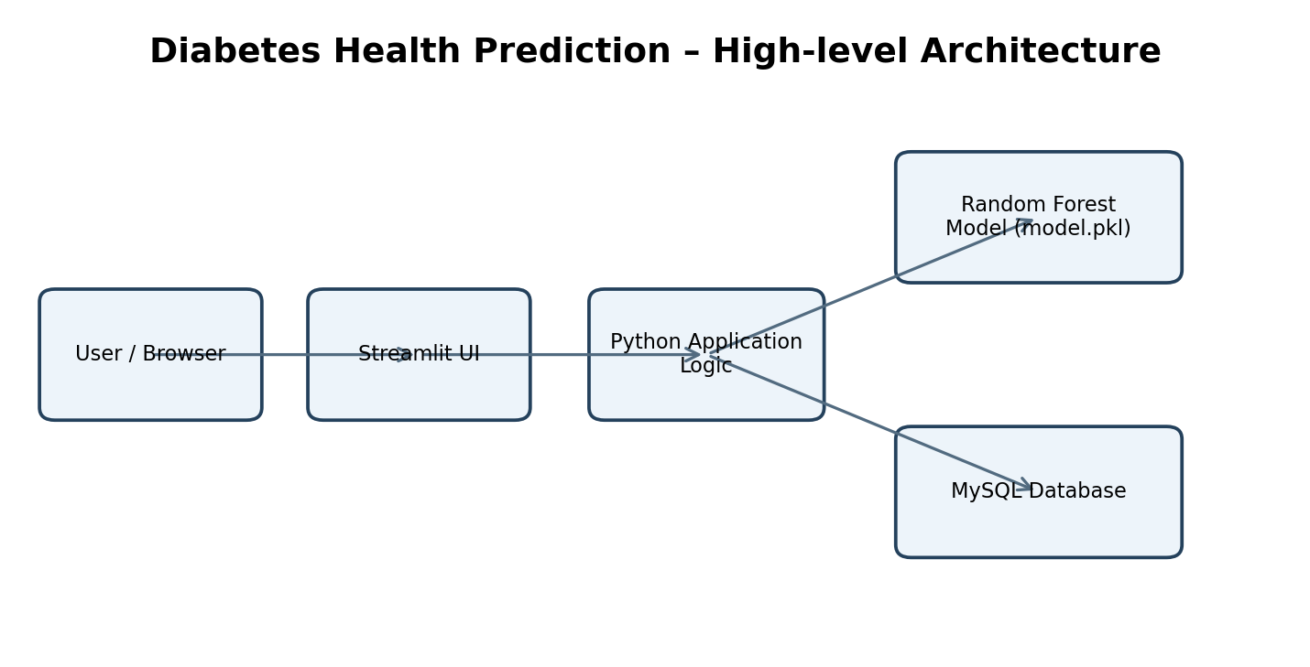
Figure: 3.5 System Architecture

3.6 Data Flow Diagram – Level 0
The Level 0 data flow diagram presents the application as one overall process. The registered user supplies account details and health attributes and receives assessment results, saved history and related dashboard information. The system communicates with the machine-learning model to calculate a class and estimated probability and with the database to persist account, family, assessment and reminder records.
The diagram is a logical representation. It does not expose every SQL query or internal Python function. The administrator is an additional actor for administrative functions; the context diagram focuses on the main user-to-system interaction and the model/database dependencies.
Data stores are not shown as separate physical servers because the supplied code only defines a MySQL connection interface and a serialized local model artifact. The exact cloud topology is not established by the source archive.
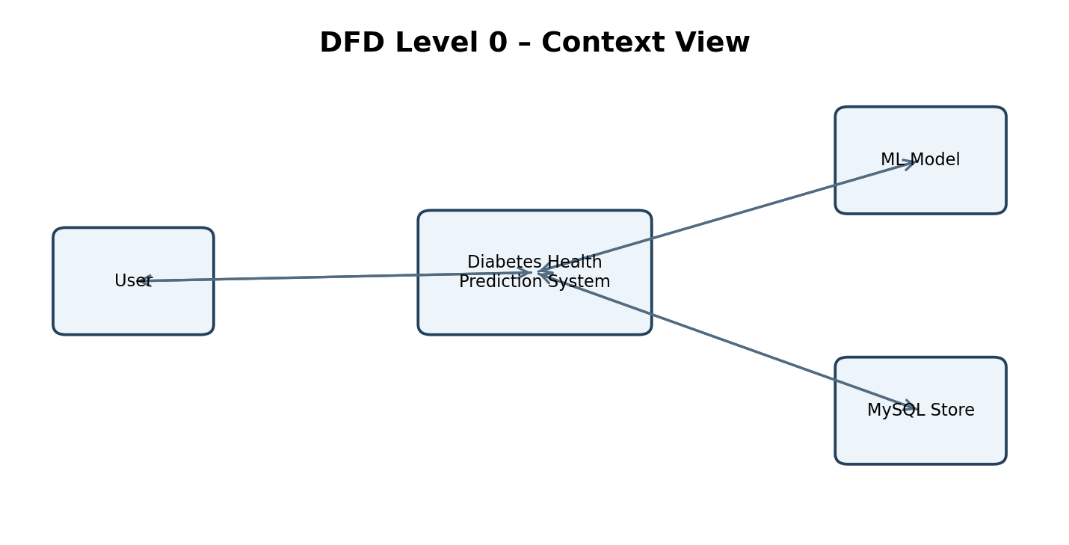
Figure: 3.6 Data Flow Diagram – Level 0

3.7 Data Flow Diagram – Level 1
The Level 1 diagram decomposes the assessment transaction into input capture, validation and encoding, model prediction, result presentation and persistence. The input stage collects age, gender, BMI, HbA1c, blood glucose, hypertension, heart-disease status and smoking history. The validation stage checks required name and gender selections and maps categorical values into numeric codes.
The prediction stage passes the values in the fixed order expected by the model: gender, age, hypertension, heart disease, smoking history, BMI, HbA1c and glucose. The model returns a class label and probability array. The application finds the index of class 1 in model.classes_ and multiplies that probability by 100 to display a percentage.
The persistence stage writes the original measurements, categorical status, predicted class and risk percentage into the assessments table. A member_id is stored when the assessment subject is a family member; it remains NULL for the logged-in user's personal assessment.
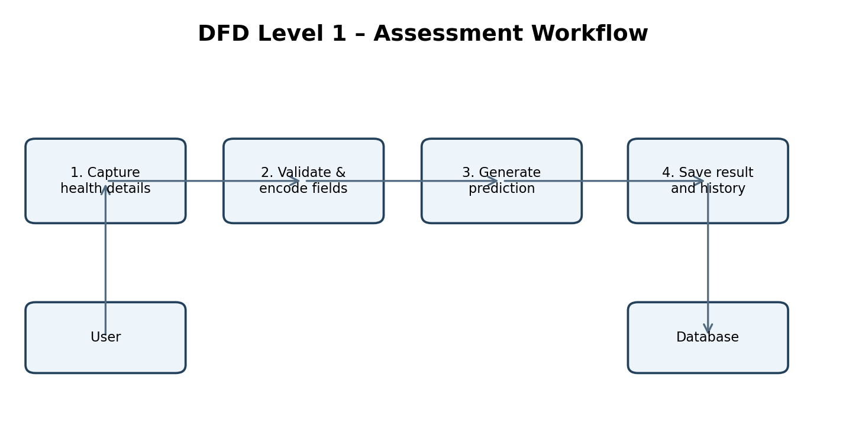
Figure: 3.7 Data Flow Diagram – Level 1

3.8 UML Use-case Overview
The principal registered-user use cases are sign up, log in, update profile, perform assessment, view personal assessment history, manage family members, review family history, view analytics, track progress, create reminders and access health reports. The application source also includes a health knowledge page and an administrator login/dashboard workflow.
The use-case diagram groups related pages into user-facing tasks. It is an overview prepared from the application functions and is not a complete formal UML specification. A production requirements specification should define preconditions, postconditions, alternate flows and authorization rules for each use case.
An administrator should be treated as a separate role. The SQL schema contains an admins table and the source includes admin_login and admin_dashboard functions. Administrative actions must be restricted to authorized administrator accounts and tested separately from ordinary user workflows.
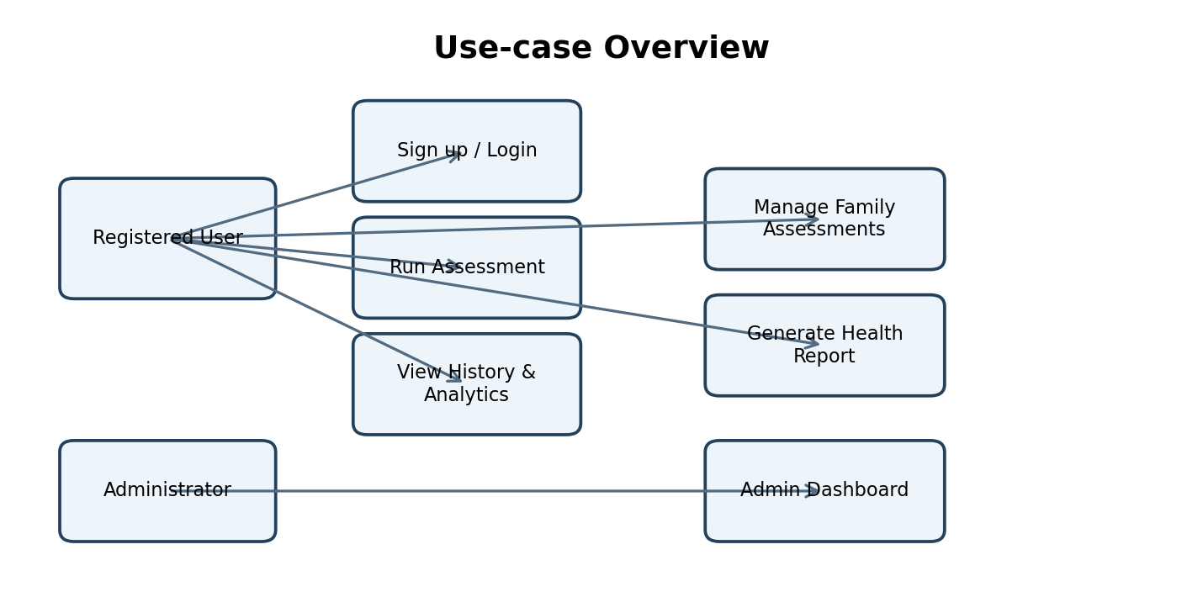
Figure: 3.8 UML Use-case Overview

3.9 Prediction Workflow and Activity Logic
The prediction workflow begins after a user has opened the assessment page. The form captures a subject name and health attributes. On submission, the code trims the name and verifies that it is not empty and that a gender option has been selected. If the entered name matches the logged-in user's name, the assessment is treated as personal. Otherwise, the code searches for an existing family member under the current user and inserts a new family-member record when no match is found.
Categorical values are converted to integers using explicit mappings. Male is encoded as 1 and Female as 0. Hypertension and heart disease are encoded as 1 for Yes and 0 for No. Smoking history uses the mapping Never=0, No Info=1, Current=2, Former=3, Ever=4 and Not Current=5. The order and meaning of these encodings must remain consistent with the training dataset.
The model predicts a binary class and returns class probabilities. The positive class is identified by locating the value 1 in model.classes_. The resulting probability is converted to a percentage. The interface labels results below 30% as lower estimated risk, from 30% through below 70% as elevated estimated risk, and 70% or above as higher estimated risk. These are display bands in the code, not clinical thresholds.
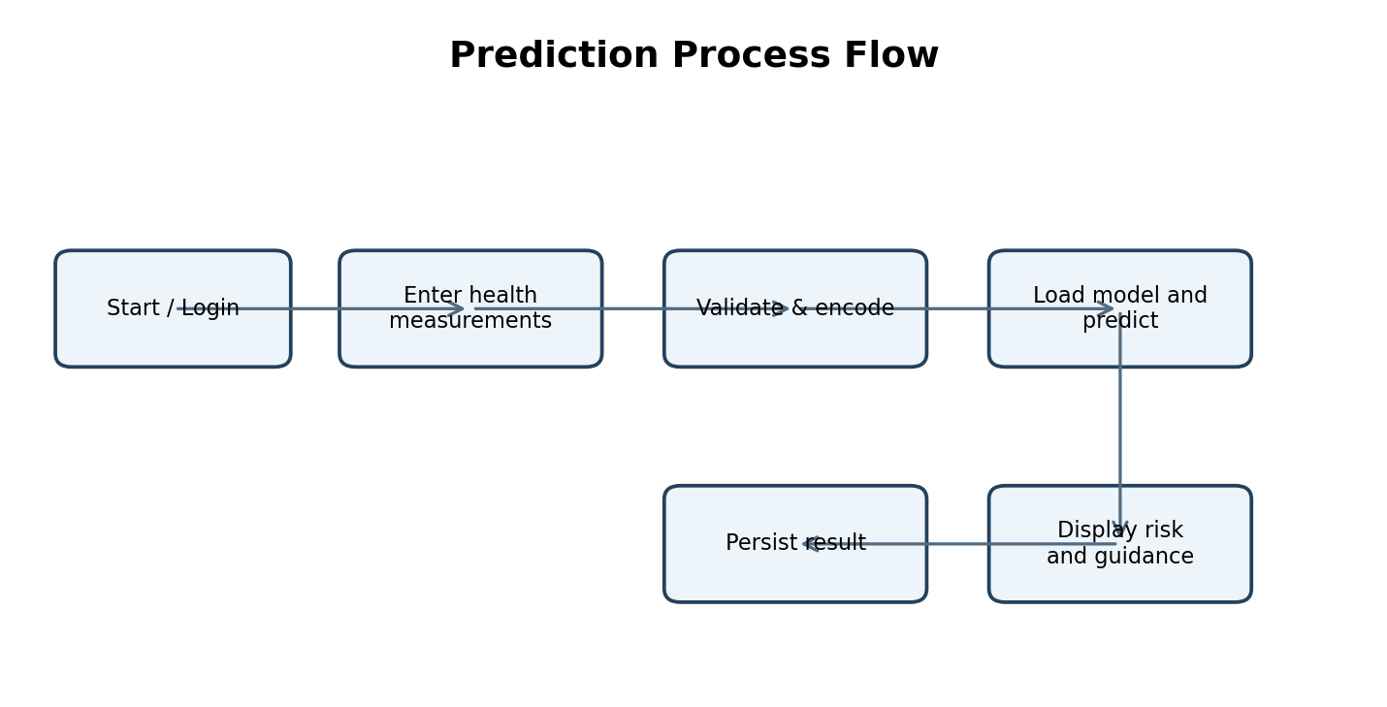
Figure: 3.9 Prediction Workflow and Activity Logic

3.10 Database Design – Overview
The SQL dump defines five tables. users stores registered account details and profile-photo paths. admins stores administrator identity and password hashes. family_members stores named subjects associated with a user. assessments stores each assessment's measurements, classification, probability and timestamp. reminders stores a user's reminder title, type, date, time, notes and completion state.
The design uses integer primary keys with auto-increment behavior. User email addresses are unique in the users table, and administrator email addresses are unique in admins. Assessments contain user_id and an optional member_id. Family-member rows contain user_id. Reminders contain user_id. The SQL dump declares indexes for these identifier fields.
The supplied SQL file creates primary keys and indexes but does not visibly declare foreign-key constraints. The logical relationships described in the ER diagram should therefore be understood as application-level relationships in the supplied schema. Adding explicit foreign-key constraints with appropriate deletion rules would improve referential integrity in a future revision.
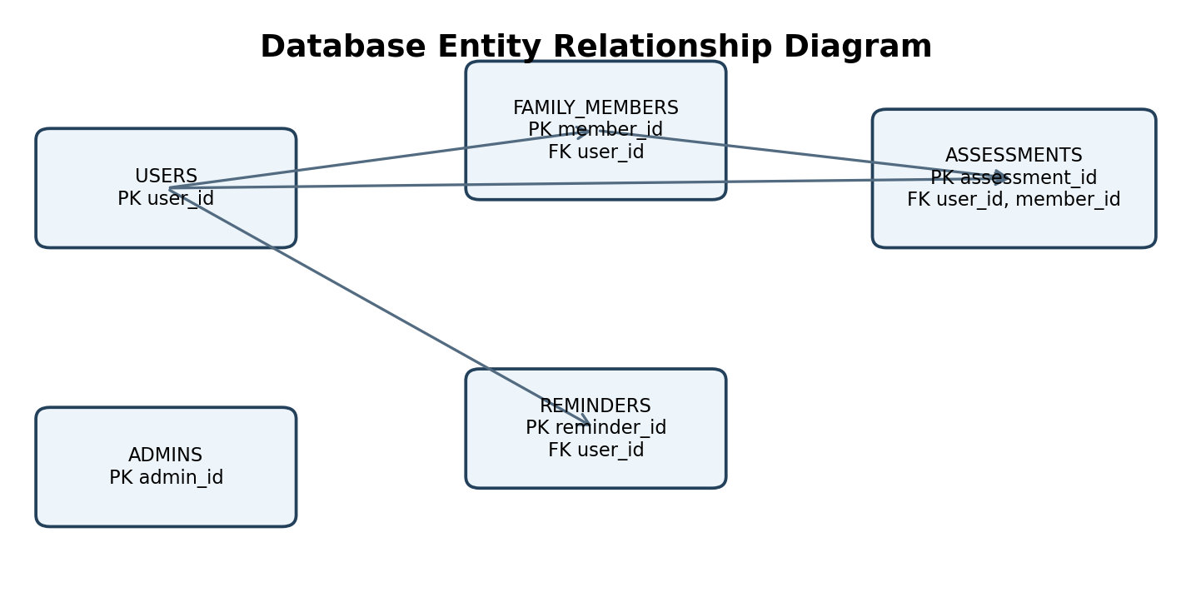
Figure: 3.10 Database Design – Overview

3.11 Entity Relationship Diagram
The ER diagram shows one user associated with multiple family members, multiple assessments and multiple reminders. Each family member belongs to one user and may be referenced by multiple assessment rows. An assessment always references a user and may optionally reference a family member. The admins table is separate from the user-facing relationship model.
The assessment table records the attributes used by the model: age, gender, BMI, HbA1c, blood glucose, hypertension, heart disease and smoking history. It also records the predicted class and risk probability. The created_at timestamp supports chronological history and trend views.
The schema should be reviewed before production use. Explicit foreign keys, indexes aligned with common query patterns, data retention policies, input constraints and transaction handling should be considered. Sensitive sample records in the SQL dump should not be reused in a public demonstration or report without appropriate anonymization.
Figure: 3.11 Entity Relationship Diagram

3.12 Data Dictionary – User and Account Tables
The users table stores account-level information. user_id is the primary key. full_name and email are required text fields, email is unique, password stores a password hash rather than plaintext in the sample schema, profile_photo is an optional path and created_at records the account creation timestamp.
The admins table stores admin_id, admin_name, email, password and created_at. The administrator email is unique. The supplied SQL data contains a hashed password string, demonstrating that the database is intended to store a password hash. The report intentionally omits personal email addresses and sample password hashes from the source dump.
Profile images are represented by a path in the database and stored under the static/uploads/profile directory in the archive. A production implementation should validate image content and file size, generate safe server-side filenames, prevent path traversal and ensure that users can access only their own profile images.
Table | Field | Purpose
users | user_id | Primary key
users | full_name | Registered user's display name
users | email | Unique login identifier
users | password | Stored password hash
users | profile_photo | Optional image path
users | created_at | Account creation timestamp
admins | admin_id | Administrator primary key
admins | admin_name / email | Admin identity and unique login
admins | password / created_at | Password hash and creation time

3.13 Data Dictionary – Assessment and Related Tables
The assessments table is the core transactional table. It stores assessment_id, user_id, optional member_id, age, gender, BMI, HbA1c, blood_glucose, hypertension, heart_disease, smoking_history, prediction, risk_probability and created_at. The prediction field is a binary value and risk_probability is a decimal field intended to store a percentage.
The family_members table contains member_id, user_id, name and created_at. It allows an account holder to create named family subjects. The reminders table contains reminder_id, user_id, title, reminder_type, reminder_date, reminder_time, notes, is_completed and created_at. The is_completed field defaults to zero.
Data types and nullability are defined in the SQL dump. The database does not show a separate table for model versions, prediction explanations, consent records or audit events. Such tables may be valuable if the application is extended to regulated or production health-data use.
Table | Key fields | Description
assessments | assessment_id, user_id, member_id | Inputs, output and timestamp
family_members | member_id, user_id | Family subject records
reminders | reminder_id, user_id | Scheduled task details and status

3.14 Assessment Feature Dictionary and Encoding
The assessment interface accepts eight model features. Their numeric representation must match the training dataset and model input schema. The code creates a single-row NumPy array in a fixed order and passes it directly to the model. The code does not show a named preprocessing pipeline object or feature-name validation step at inference time.
Gender is converted to a binary value, with Male=1 and Female=0. Hypertension and heart disease use No=0 and Yes=1. Smoking history is mapped to six integer categories. Age, BMI, HbA1c and blood glucose are numeric inputs. The form constrains age to 1–120, BMI to 1.0–80.0, HbA1c to 1.0–20.0 and glucose to 1–500.
An important technical caveat is that integer codes for categories can imply an ordering that may not be semantically meaningful. The training notebook reads the CSV and trains directly on the columns; the exact dataset feature definitions and category coding must be confirmed against the CSV before retraining or changing the interface. A ColumnTransformer or pipeline with explicit categorical encoding would improve reproducibility.
Feature order | Input | Inference encoding
1 | Gender | Male=1; Female=0
2 | Age | Integer years
3 | Hypertension | Yes=1; No=0
4 | Heart disease | Yes=1; No=0
5 | Smoking history | Never=0; No Info=1; Current=2; Former=3; Ever=4; Not Current=5
6 | BMI | Numeric, one decimal
7 | HbA1c | Numeric, %
8 | Blood glucose | Numeric, mg/dL

3.15 Security, Privacy and Validation Design
The application imports Werkzeug's generate_password_hash and check_password_hash functions. This indicates a password-hashing approach for account credentials. SQL statements in the assessment workflow use placeholders and parameter tuples, which is preferable to constructing SQL strings by concatenating user input.
Validation includes a required subject name and a required gender selection. Numeric widgets impose minimum and maximum ranges for several measurements. Additional validation should check plausible values, missing values, whitespace, duplicate family names, date/time consistency and the ownership of requested database records.
Because the project processes health-related information, privacy should be treated as a core design requirement. The sample SQL file includes personal names and email addresses; these have not been reproduced in the report. Before public distribution, remove or anonymize real records, rotate any exposed credentials, avoid committing secrets, restrict database permissions and define access, retention and deletion rules.

4.1 Development Environment
The project is implemented primarily in Python. The main entry point is streamlit_app.py, while database.py contains the database connection helper. The archive includes a requirements.txt file that lists the libraries needed by the application. The implementation notebook contains the model-training steps and writes the serialized estimator to model.pkl.
The source code imports Streamlit for the interface, pandas and NumPy for data handling, pickle for model loading, Plotly Express and Graph Objects for visualizations, Pillow for image operations, datetime utilities, MySQL Connector/Python for database access and Werkzeug for password hashing. ReportLab is imported in the application for PDF-related report generation.
The source archive does not include a pinned environment lockfile or exact package versions. For reproducible deployment, record Python and library versions, test compatibility between the training and runtime environments and consider using a virtual environment or container.
Technology | Role in project
Python | Application logic and model workflow
Streamlit | Browser-based interactive interface
pandas / NumPy | Dataset and feature-array processing
scikit-learn | Classification model training and inference
MySQL Connector/Python | Database connectivity
Plotly | Interactive charts
Werkzeug | Password hashing and verification
Pillow | Image handling
ReportLab | PDF/report generation support

4.2 Dataset Preparation
The implementation notebook loads Diabetic_Prediction.csv using pandas read_csv. It then removes a column named Unnamed: 0, which appears to be an exported index column. The target variable is diabetes, and the predictor matrix is created by dropping that target column from the dataframe.
The notebook uses train_test_split with test_size=0.2, random_state=42 and stratify=y. This allocates 80 percent of the records to training and 20 percent to testing while preserving the target-class proportions as far as the stratification procedure allows. A fixed random state supports repeatable partitioning.
The notebook does not show a detailed data-cleaning report, missing-value treatment, outlier analysis, feature scaling, category encoding pipeline or external validation split. These steps should be investigated before interpreting performance. The report therefore describes the supplied preparation code without claiming that all possible data-quality checks were completed.

4.3 Exploratory Data Review and Feature Selection
The notebook defines X as all columns other than diabetes and y as the diabetes target. The supplied application expects eight predictors: gender, age, hypertension, heart disease, smoking history, BMI, HbA1c and blood glucose. This establishes the feature interface that must be compatible with the training dataset.
The CSV is part of the uploaded archive, but its complete statistical profile is not embedded in the notebook. Before final academic submission, the student should run a dataset audit and record the row count, column names, data types, missing-value counts, duplicate count and target-class distribution. These are measurable dataset properties and should be copied from an actual execution rather than estimated.
Feature selection is implemented by using all non-target columns after dropping the unnamed index. The notebook does not show a separate feature-selection algorithm. A future revision could compare feature importance, permutation importance and domain-informed feature sets while ensuring that all choices are made using training data only.

4.4 Model Selection and Training
The implementation notebook imports four classifiers: LogisticRegression, DecisionTreeClassifier, RandomForestClassifier and KNeighborsClassifier. Each estimator is fitted on the training partition. The notebook then computes accuracy on the held-out test partition for each of the four initial estimators.
After this comparison, the notebook creates a RandomForestClassifier with n_estimators=100, random_state=42 and class_weight='balanced'. The model is fitted again on the training data. The balanced class-weight option adjusts the training contribution of classes according to their frequencies, which can be useful when class counts differ.
The final fitted Random Forest is saved to model.pkl using pickle.dump. The Streamlit application loads this artifact at startup. The notebook includes code to compute a confusion matrix, classification report and ROC-AUC score, but the supplied notebook contains code cells rather than saved numeric outputs. Consequently, no accuracy, precision, recall, F1 or AUC value is asserted in this report.
Candidate | Purpose
Logistic Regression | Linear classification baseline
Decision Tree | Rule-based tree classifier
Random Forest | Ensemble of decision trees; selected final model
K-Nearest Neighbors | Distance-based classification baseline

4.5 Random Forest Model – Concept
Random Forest is an ensemble learning method that combines predictions from multiple decision trees. During training, trees are generally built using bootstrap samples and randomized feature subsets. For classification, the ensemble aggregates the tree-level outputs to produce a class prediction and class probabilities.
The project configures 100 trees and a fixed random state of 42. A fixed seed supports repeatability under the same software and data conditions. The class_weight='balanced' parameter adjusts class weights inversely in relation to class frequencies as estimated by the training labels.
The model's predict method returns a class label. Its predict_proba method returns probabilities for each class in the order indicated by model.classes_. The application locates the position of class 1 rather than assuming it is always the second column, then converts the selected probability into a percentage.

4.6 Model Evaluation Methodology
The notebook imports accuracy_score to compare candidate models. Accuracy is the fraction of test examples classified correctly. However, accuracy alone may be misleading when the target classes are imbalanced. The notebook also imports classification_report and confusion_matrix, which provide class-wise precision, recall, F1-score and counts of true/false classifications.
The notebook calculates ROC-AUC using the predicted probability for class 1. ROC-AUC measures ranking discrimination across thresholds; it does not by itself establish clinical usefulness, calibration or a suitable operating threshold. A model can achieve a strong ranking metric while still producing poorly calibrated probabilities or unequal error rates across demographic groups.
The supplied notebook does not preserve output values. The final report should include actual metric results only after rerunning the notebook in the intended environment and confirming the dataset version, split and library versions. A stronger evaluation would add cross-validation, calibration analysis, subgroup evaluation and independent external validation.
Metric | Meaning | Interpretation caution
Accuracy | Overall proportion correct | Can hide minority-class errors
Precision | Positive predictions that are correct | Important when false positives matter
Recall | Actual positives correctly identified | Important when false negatives matter
F1-score | Harmonic mean of precision and recall | Balances precision and recall
Confusion matrix | Counts of TP, TN, FP and FN | Shows error types
ROC-AUC | Ranking discrimination across thresholds | Not calibration or clinical validation

4.7 Model Serialization and Loading
After fitting, the notebook serializes the Random Forest estimator into model.pkl. The Streamlit application imports pickle and executes pickle.load(open('model.pkl', 'rb')) during startup. This approach allows the deployed application to reuse the trained estimator without fitting it on every user request.
Serialization requires compatible software and a trusted model artifact. Pickle is Python-specific and can be unsafe when loading untrusted files. The model should be stored in a controlled repository or artifact store, verified before deployment and versioned with the dataset, training script and library versions.
A recommended improvement is to store model metadata alongside the artifact, including training date, source dataset checksum, feature names and order, target definition, package versions, evaluation metrics and intended use limitations. The application could validate expected feature names and model version before accepting predictions.

4.8 Model Integration with Streamlit
The model is loaded once at application startup and retained in the module-level variable model. When a user submits an assessment, the application constructs a NumPy array containing one row and eight columns. The array is passed to model.predict and model.predict_proba.
The application obtains model.classes_, finds the index of class 1 and selects the corresponding probability. Multiplying the probability by 100 converts it to a percentage for display and database storage. The result section displays the percentage and assigns a presentation label according to the configured 30% and 70% boundaries.
The application includes a clear disclaimer that the result is not a medical diagnosis and advises users to consult a qualified healthcare professional if concerned. This disclaimer is essential and should remain visible wherever the model output is shown.

4.9 Module 1 – User Registration and Login
The user access module provides sign-up and login pages. The source contains a signup_page function that checks whether an email already exists and inserts a new user record. Password hashing and verification are handled through Werkzeug functions imported by the application. User identity and login state are stored in Streamlit session state.
The session state includes flags and identifiers such as logged_in, user_id and user_name. The initial values are set when the application starts a new session. Page navigation and access checks use these values to determine which interface should be displayed.
Authentication should be tested for duplicate email addresses, incorrect passwords, empty fields, session refresh, logout, direct page navigation and attempts to access another user's records. A production version should use robust session expiry, secure cookie settings and authorization checks on every database operation.

4.10 Module 2 – User Profile
The profile_page function provides a profile view and account-information section. The application stores a profile-photo path in the users table and includes uploaded profile images in the static/uploads/profile directory. Pillow is imported for image operations.
The profile page is part of the account-management workflow and is intended to let a signed-in user review or maintain personal information. The database design separates profile data from assessment transactions, allowing the user's account to persist while multiple assessments are created.
Image upload workflows should be checked for supported formats, file size, image decoding errors, duplicate filenames and access control. The supplied source should be reviewed in the final environment to confirm the exact editable profile fields and validation rules before this description is made more specific.

4.11 Module 3 – Diabetes Assessment
The assessment_page function is the core feature of the project. It asks for the subject's name, age, gender, BMI, HbA1c, blood glucose, hypertension, heart-disease status and smoking history. Numeric widgets define input ranges, and select boxes constrain categorical choices.
On submission, the function validates the name and gender. It identifies whether the subject is the current user or a family member, creates a family record if needed, encodes the categorical values, forms the model input vector, performs inference and saves the assessment. The result includes the estimated risk percentage and a qualitative band.
The page displays a safety message that the model output is not a medical diagnosis. The result is stored in the assessments table with the user's identifier, optional family-member identifier, health inputs, prediction, probability and timestamp.

4.12 Module 4 – Family Member Management
The family-member module allows a user to maintain a list of named people under the account. The family_members table uses member_id as its primary key and user_id to associate each person with the account holder. The assessment workflow searches for a family member by name within the current user's records and creates a new row when no matching record is found.
Assessment rows include an optional member_id. This permits the application to distinguish personal assessments from assessments for a named family member. The family history and family analytics pages use these associations to retrieve and visualize related records.
Name matching is case-insensitive in the assessment lookup query, but names are not guaranteed to be unique in real households. A future version should use a stable member selection identifier rather than free-text matching alone and should allow users to edit, archive or delete family-member records under clear retention rules.

4.13 Module 5 – History, Analytics and Progress
The application includes pages for personal assessment history, family history, personal analytics, family analytics, dataset analytics, a general analytics page and progress tracking. These modules use database queries and pandas dataframes to organize stored assessments and create visual summaries.
Plotly Express and Plotly Graph Objects are imported for charts. The code includes chart styling functions and data-retrieval helpers for personal and family analytics. Historical analysis can help users inspect the pattern of entered values and model outputs over time, but it should not be interpreted as a validated clinical trend unless measurement conditions and data quality are controlled.
Analytics should display clear date ranges, sample counts, missing-data handling and labels. Small numbers of records can produce unstable patterns. Charts should avoid implying that a change in model probability is a change in diagnosed disease status.

4.14 Module 6 – Reminders and Health Knowledge
The reminders module stores reminder title, type, date, time, optional notes and completion status. The reminders table associates each reminder with a user_id. The code includes an INSERT statement for creating reminder records and a display helper for dashboard reminders.
The health knowledge page provides informational content in the application. It should be treated as general educational material and reviewed against reliable medical sources before publication. Content should include dates or references where appropriate and avoid giving personalized treatment advice.
Reminder records are stored in the database; the presence of a reminder entry does not prove that the application sends a push notification, SMS or email. Unless a notification integration is separately verified, describe reminders as in-app task records rather than automated alerts.

4.15 Module 7 – Health Reports and Administrator Dashboard
The source includes a generate_health_report function and a reports_page. Report generation imports ReportLab components, including document, paragraph, table and style utilities. The report module retrieves assessment data and prepares a formatted health report for the selected record.
The administrator workflow includes admin_login and admin_dashboard functions. The dashboard queries counts such as total users, total predictions, positive and lower-risk prediction counts, family members, today's predictions and average risk probability. It also provides registered-user, assessment-record and family-member views.
Administrator access has a higher level of privilege and should be secured carefully. The application should restrict administrator creation, verify access control, log sensitive operations and avoid exposing full personal information unnecessarily. Aggregate statistics should be presented with context and should not be treated as epidemiological findings.

4.16 Database Connectivity and SQL Operations
The database.py helper defines get_db_connection. If a mysql section exists in st.secrets, the helper connects using the configured host, port, user, password and database. Otherwise, it connects to localhost with the database name diabetes_health and a local root account with an empty password, which is a development convenience and not a secure production configuration.
The application uses mysql.connector and executes parameterized statements. Database cursors and connections are generally closed in finally blocks in key workflows. Writes are committed after successful inserts. This pattern helps avoid leaving open resources and ensures inserted records are persisted.
Production deployment should not use a blank database password or a root database account. It should use a dedicated least-privilege database user, TLS where supported, managed secrets and a documented backup/restore process. Database connection pooling and retry behavior may also be considered as traffic grows.

4.17 User Interface Design and Navigation
The application configures a wide Streamlit layout and an expanded sidebar. It applies a dark visual theme with light text, accent borders and styled buttons. The navbar displays a logo and the product name “Diabetes Health” with the tagline “Understand • Track • Take Action”.
The sidebar provides navigation to the dashboard, assessment and other account functions. The application uses Streamlit session state to track the current page, dashboard page, login status, user identifier, user name and selected family-member context. Button interactions update state and trigger a rerun.
Usability improvements could include keyboard navigation testing, consistent form error placement, accessible color contrast, explicit units beside every measurement, explanatory tooltips and responsive testing on mobile screens. A user should understand that a probability estimate is model output rather than a clinical probability without validation.

4.18 Screens of the Application
This section presents the main screens of the Diabetes Health Prediction application in the order in which a user would normally access its features. Capture each screen directly from the running Streamlit application. Use a test account and dummy health values only. Replace every grey placeholder below with the corresponding genuine application screenshot; do not use sample or fabricated interface images.
Figure 4.1: Home page of the Diabetes Health Prediction application
[INSERT AUTHENTIC APPLICATION SCREENSHOT HERE]
Suggested image size: approximately 6.0 in wide. Keep the full page controls and readable text visible.
Screenshot instructions: Capture the first page visible at the deployed Streamlit URL before login. Include the application name, introductory text, navigation, and visible Login/Sign Up actions.
Figure 4.2: User registration page
[INSERT AUTHENTIC APPLICATION SCREENSHOT HERE]
Suggested image size: approximately 6.0 in wide. Keep the full page controls and readable text visible.
Screenshot instructions: Capture the complete sign-up form, including the fields and Create Account/Register action. Do not show a real email, phone number, or password.
Figure 4.3: User login page
[INSERT AUTHENTIC APPLICATION SCREENSHOT HERE]
Suggested image size: approximately 6.0 in wide. Keep the full page controls and readable text visible.
Screenshot instructions: Capture the login form and any links to registration or admin login. Use a dummy account; hide credentials.

Figure 4.4: User dashboard
[INSERT AUTHENTIC APPLICATION SCREENSHOT HERE]
Suggested image size: approximately 6.0 in wide. Keep the full page controls and readable text visible.
Screenshot instructions: Capture the dashboard immediately after a successful user login. Include the navigation/sidebar and the dashboard overview/cards or welcome area.
Figure 4.5: Diabetes assessment input form
[INSERT AUTHENTIC APPLICATION SCREENSHOT HERE]
Suggested image size: approximately 6.0 in wide. Keep the full page controls and readable text visible.
Screenshot instructions: Capture the assessment page before submitting. Ensure the visible input fields include the demographic and health variables used by the model, such as age, BMI, HbA1c/glucose and relevant medical-history selections, as available on the page.

Figure 4.6: Diabetes prediction result
[INSERT AUTHENTIC APPLICATION SCREENSHOT HERE]
Suggested image size: approximately 6.0 in wide. Keep the full page controls and readable text visible.
Screenshot instructions: Capture the result shown after submitting a valid dummy assessment. Include the predicted outcome, displayed probability/risk information if present, and any explanatory or recommendation text. Do not present it as a medical diagnosis.
Figure 4.7: My Assessment / assessment history page
[INSERT AUTHENTIC APPLICATION SCREENSHOT HERE]
Suggested image size: approximately 6.0 in wide. Keep the full page controls and readable text visible.
Screenshot instructions: Capture the page listing the logged-in user’s previous assessment records. Use dummy records and conceal personal identifiers.

Figure 4.8: Family members assessment page
[INSERT AUTHENTIC APPLICATION SCREENSHOT HERE]
Suggested image size: approximately 6.0 in wide. Keep the full page controls and readable text visible.
Screenshot instructions: Capture the family-member list or add-member interface. Use fictional names and data only.
Figure 4.9: Family member assessment history
[INSERT AUTHENTIC APPLICATION SCREENSHOT HERE]
Suggested image size: approximately 6.0 in wide. Keep the full page controls and readable text visible.
Screenshot instructions: If the application provides the family-history view, capture a selected dummy family member’s assessment/history details.

Figure 4.10: Analytics dashboard
[INSERT AUTHENTIC APPLICATION SCREENSHOT HERE]
Suggested image size: approximately 6.0 in wide. Keep the full page controls and readable text visible.
Screenshot instructions: Capture the Analytics page showing the charts, summaries, or distributions available to the logged-in user.
Figure 4.11: Progress tracking page
[INSERT AUTHENTIC APPLICATION SCREENSHOT HERE]
Suggested image size: approximately 6.0 in wide. Keep the full page controls and readable text visible.
Screenshot instructions: Capture the Progress page, including any trend, comparison, or progress indicators visible in the application.

Figure 4.12: Reminders page
[INSERT AUTHENTIC APPLICATION SCREENSHOT HERE]
Suggested image size: approximately 6.0 in wide. Keep the full page controls and readable text visible.
Screenshot instructions: Capture the Reminders page, including the reminder list or add-reminder form, using a fictional reminder.
Figure 4.13: Health knowledge page
[INSERT AUTHENTIC APPLICATION SCREENSHOT HERE]
Suggested image size: approximately 6.0 in wide. Keep the full page controls and readable text visible.
Screenshot instructions: Capture the Health Knowledge page showing educational information/cards or articles provided by the application.

Figure 4.14: Reports page
[INSERT AUTHENTIC APPLICATION SCREENSHOT HERE]
Suggested image size: approximately 6.0 in wide. Keep the full page controls and readable text visible.
Screenshot instructions: Capture the Reports page and, if available, the generated/downloadable report preview. Use dummy account data.
Figure 4.15: User profile page
[INSERT AUTHENTIC APPLICATION SCREENSHOT HERE]
Suggested image size: approximately 6.0 in wide. Keep the full page controls and readable text visible.
Screenshot instructions: Capture the Profile page showing profile information and edit controls. Blur or replace personal details with dummy values.

Figure 4.16: Administrator login and dashboard
[INSERT AUTHENTIC APPLICATION SCREENSHOT HERE]
Suggested image size: approximately 6.0 in wide. Keep the full page controls and readable text visible.
Screenshot instructions: Capture the Admin Portal login and, after authorized test access, the Admin Dashboard. If the report layout permits only one image, use the dashboard and mention the login screen in the caption text. Never expose admin credentials or real user records.

4.19 Implementation and Deployment Process
A reproducible local setup begins by installing a compatible Python version and the packages listed in requirements.txt. The MySQL or MariaDB service must be started, the diabetes_health database created and the supplied SQL file imported. The local database configuration in database.py expects a localhost service and database name diabetes_health.
The model.pkl, Diabetic_Prediction.csv, Logo.png and streamlit_app.py files must be present in the working directory expected by the application. The application can then be started using Streamlit's command-line interface. In a hosted environment, database connection settings must be configured in Streamlit secrets rather than hard-coded credentials.
The repository is publicly hosted on GitHub. The associated Streamlit URL was supplied by the project owner, but the inspection environment redirected to an authentication endpoint and did not permit independent rendering. Therefore, the report documents the source implementation and treats deployed screen captures as items for the student to insert after opening the application in a normal browser.
- Local setup: install requirements; configure MySQL; import diabetes_health.sql; verify model/data/assets; run Streamlit.
- Hosted setup: deploy source; configure Streamlit secrets; provision database; verify runtime dependencies; test access and data persistence.

4.20 Coding Evidence and Important Source Files
The most important application file is streamlit_app.py. It contains page functions, navigation, session-state initialization, assessment processing, analytics queries, report generation and administrative views. database.py isolates the connection configuration from the main application.
Implementation.ipynb documents the training pipeline. It loads the CSV, separates the target, creates a stratified train/test split, fits candidate classifiers, evaluates them and serializes the final Random Forest. diabetes_health.sql defines the relational tables and sample records. requirements.txt declares the runtime libraries.
Insert genuine screenshots of the source code and application at the marked locations in the final Word document. Recommended evidence includes the model training cells, assessment form, result message, database tables, analytics chart and report output. Redact email addresses, user names, passwords, tokens and any other personal information before capturing screenshots.
File | Role
streamlit_app.py | Main UI and application logic
database.py | MySQL connection helper
Implementation.ipynb | Model training and evaluation code
model.pkl | Serialized trained classifier
Diabetic_Prediction.csv | Training dataset
diabetes_health.sql | Database schema and sample data
requirements.txt | Dependency list

4.21 Implementation Review and Improvement Opportunities
The supplied implementation demonstrates a complete prototype workflow, but several engineering improvements would strengthen maintainability and reproducibility. The input feature order is manually assembled in a NumPy array. A named preprocessing pipeline and explicit feature schema would reduce the chance of accidental mismatch between training and inference.
The application loads the pickle model at module import time. Model metadata, version checks and safer artifact management would make deployment more transparent. The notebook compares models but does not save the metric outputs. A reproducible evaluation script should export metrics and the confusion matrix to a versioned report.
The SQL schema uses indexes and primary keys but does not declare visible foreign-key constraints. Adding referential integrity, database migrations, audit logging and automated tests would improve robustness. Security work should include least-privilege database access, secrets hygiene, authorization testing and data minimization.

5.1 Testing Strategy
Testing verifies that the application behaves as intended under normal, boundary and error conditions. The project should be tested at several levels: unit tests for encoding and risk calculation, integration tests for database writes and reads, interface tests for form validation and end-to-end tests for the full assessment journey.
Testing should cover both personal and family assessments. A personal assessment should store a NULL member_id. A family assessment should either reuse the correct existing member record or create a new family-member record before saving the assessment. The stored prediction and probability should correspond to the model output for the same input vector.
The supplied archive does not include a formal automated test suite or test execution logs. The test cases below are therefore a recommended manual test plan. Mark each result as Pass or Fail only after executing the test against the local or deployed application and recording the actual evidence.
Test level | Purpose | Evidence
Unit | Encoding and probability calculation | Assertions / unit-test output
Integration | Model and database interaction | Stored row and returned result
System | Complete user workflow | Screen recording / screenshots
Security | Authentication and ownership checks | Test log with redacted data
Usability | Clarity and navigation | User feedback form

5.2 Functional Test Cases – Authentication and Profile
Authentication tests should verify account creation, duplicate email handling, successful login, incorrect-password rejection and logout behavior. Profile tests should verify that a user's own information is displayed and that profile-image handling does not permit access to another user's private content.
Every test should record the test ID, preconditions, input, expected result, actual result, status and evidence reference. The tester should use dedicated dummy accounts and synthetic data. Do not use real health information or personal email addresses in screenshots included in an academic report.
The table below provides a template test set. The student should replace the pending status with the observed result after executing the test in the actual application.
ID | Test scenario | Expected result | Status
TC-01 | Register with valid details | Account created and stored | [PENDING]
TC-02 | Register with existing email | Duplicate registration prevented | [PENDING]
TC-03 | Login with correct credentials | User session established | [PENDING]
TC-04 | Login with incorrect password | Access denied with message | [PENDING]
TC-05 | Open profile while logged in | Own profile information displayed | [PENDING]
TC-06 | Access profile without login | Redirect or access denied | [PENDING]

5.3 Functional Test Cases – Assessment
Assessment tests should verify required fields, numeric boundaries, categorical mapping, model invocation, probability formatting and database persistence. The test should confirm that the submitted vector uses the same order as the training features and that the class-1 probability is selected using model.classes_.
Boundary tests should include the minimum and maximum allowed values for age, BMI, HbA1c and glucose. Additional invalid-value tests should verify that Streamlit widgets prevent values outside the configured range. The form should also reject an empty name and an unselected gender.
The risk bands in the interface are lower estimated risk below 30%, elevated estimated risk from 30% to below 70%, and higher estimated risk at 70% or above. These bands are UI presentation rules, not medically validated thresholds.
ID | Test scenario | Expected result | Status
TC-07 | Submit blank person name | Validation warning shown | [PENDING]
TC-08 | Leave gender as Select | Validation warning shown | [PENDING]
TC-09 | Submit valid personal assessment | Prediction displayed and saved with NULL member_id | [PENDING]
TC-10 | Submit family assessment | Family record linked to assessment | [PENDING]
TC-11 | Repeat family name | Existing member matched | [PENDING]
TC-12 | Check result bands | Correct UI label for each band | [PENDING]
TC-13 | Database unavailable | Readable error; no false success | [PENDING]

5.4 Functional Test Cases – History, Analytics and Reports
History and analytics tests should verify that the application retrieves only records belonging to the logged-in user and that family-specific views filter records by the selected member. The displayed counts and charts should agree with the database query results for the selected date range.
Reminder tests should cover creating a reminder, displaying it, marking it complete and verifying that the completion status persists after a page refresh. Report tests should confirm that the selected assessment details appear correctly and that generated output can be opened or downloaded.
Administrator tests should verify that only an authorized admin can enter the admin dashboard and that the dashboard totals match the underlying database records. Use a test database with synthetic data and redact all identifiers in evidence.
ID | Test scenario | Expected result | Status
TC-14 | Open personal history | Only current user's records shown | [PENDING]
TC-15 | Open family history | Selected member's records shown | [PENDING]
TC-16 | Create reminder | Reminder saved and displayed | [PENDING]
TC-17 | Complete reminder | Completion status persists | [PENDING]
TC-18 | Generate health report | Report contains selected assessment | [PENDING]
TC-19 | Open admin dashboard as user | Access denied | [PENDING]
TC-20 | Open admin dashboard as admin | Authorized dashboard displayed | [PENDING]

5.5 Results Obtained – Functional Results
Source inspection confirms that the application implements the primary prediction transaction: it captures eight health features, encodes them, invokes a serialized classifier, calculates the positive-class probability, stores an assessment row and displays a result with a medical disclaimer. The database schema supports personal and family assessments.
The application source also contains functions for account registration, login, profile management, personal and family history, analytics, progress tracking, reminders, health knowledge, health reports and administrator dashboards. The SQL schema defines tables that support the main account, assessment, family-member and reminder workflows.
These are implementation findings from the source archive. They should not be confused with independently executed acceptance-test results. The student must run the application and fill in the test status table with observed outcomes before submitting the report.

5.6 Model Results and Performance Evidence
The implementation notebook defines an 80:20 stratified train-test split and evaluates four candidate classifiers using accuracy. It then fits a Random Forest with 100 estimators, random_state=42 and balanced class weights. It calculates a confusion matrix, classification report and ROC-AUC using test-set probabilities.
The supplied notebook does not contain saved outputs for these metric cells. Therefore, the exact model accuracy, precision, recall, F1-score, confusion matrix and ROC-AUC cannot be stated from the available evidence. Any numeric score copied from a different run or assumed from a similar diabetes dataset would be misleading.
To complete this section, execute Implementation.ipynb using the exact Diabetic_Prediction.csv file and the intended package versions. Record the output, include the confusion matrix and classification report, and state the split method and random seed. Ideally, also report the dataset size, class distribution and external validation status.
Evaluation item | Evidence available in source | Report status
Train/test split | 80:20, stratified, random_state=42 | Verified
Candidate models | LR, Decision Tree, RF, KNN | Verified
Final model | RF, 100 trees, balanced weights | Verified
Accuracy values | Evaluation code only; no output | Not available
Confusion matrix | Evaluation code only; no output | Not available
Classification report | Evaluation code only; no output | Not available
ROC-AUC | Evaluation code only; no output | Not available

5.7 System Performance Considerations
No formal response-time, throughput, concurrent-user or resource-utilization benchmark was included in the supplied archive. It would therefore be inappropriate to claim that the system responds within a specific number of seconds or supports a particular number of simultaneous users.
The prediction operation uses a single-row inference request against a model already loaded into memory, which avoids retraining for each user submission. Database latency, Streamlit server capacity, model size, network conditions and concurrent traffic will influence observed response time.
A performance test should measure median and 95th-percentile response times for login, assessment submission, history retrieval and report generation. It should also monitor CPU, memory, database connection counts and error rates under realistic concurrent usage. Record the test environment and sample size alongside all results.

5.8 User Feedback and Usability Evaluation
No signed user-feedback forms or structured usability study were included in the source archive. This report therefore does not attribute opinions or satisfaction ratings to actual users. The project can be evaluated through a small supervised usability exercise using a consented group of test participants and synthetic health data.
Suggested feedback topics include clarity of the assessment fields, understanding of measurement units, ease of navigation, readability of the result message, usefulness of history charts, ease of managing family members and clarity of the medical disclaimer. Ask participants whether the interface makes it clear that the estimate is not a diagnosis.
Record participant count, test tasks, questionnaire, date, summary of comments and changes made. Do not collect unnecessary personal or health information. If the institution requires human-participant approval, obtain it before conducting the evaluation.
Evaluation area | Suggested question
Ease of use | Could you complete an assessment without assistance?
Clarity | Were units and field labels understandable?
Trust and safety | Was the non-diagnostic limitation clear?
Navigation | Could you find history and reports?
Visual design | Were charts and result labels readable?

5.9 Limitations of the Current System
The model is trained from one supplied CSV dataset, and the archive does not document an independent external validation cohort. Generalization to different populations, measurement devices, data collection practices or clinical settings is unknown. The notebook does not show a complete preprocessing pipeline or probability calibration procedure.
The form accepts self-reported or manually entered data, which may contain errors. The model's output depends on the feature coding and the quality of the underlying dataset. The display bands are hard-coded presentation thresholds and are not shown to have been clinically selected.
Security and privacy controls are partial. The local database configuration uses a root account with an empty password, the SQL dump includes sample personal data, and the schema does not visibly declare foreign-key constraints. The project has no supplied automated test suite, formal performance benchmark or documented user-feedback study.

5.10 Future Scope
Future development could introduce a versioned preprocessing and prediction pipeline that validates feature names, types, ranges and category mappings. The model could be evaluated with cross-validation, calibration curves, subgroup analysis and independent datasets. Explainability tools such as feature contribution summaries could help users understand which inputs influenced a prediction, provided the explanation is carefully qualified.
Security improvements could include multi-factor authentication, secure session handling, role-based authorization, encryption, audit trails, managed secrets, database least privilege, automated backups and data deletion workflows. The schema could add foreign keys, model-version records, consent records and audit tables.
Product improvements may include multilingual support, accessible mobile layouts, clinician-reviewed educational content, exportable anonymized summaries and carefully designed integrations with health data sources. Any clinical deployment would require medical oversight, regulatory review where applicable, privacy impact assessment and prospective validation.
- Model: pipeline, calibration, external validation, fairness analysis, model cards and drift monitoring.
- Application: stronger authentication, authorization, audit trail, encryption and data retention controls.
- Usability: accessibility, responsive layout, localization and clearer measurement guidance.
- Governance: clinical review, privacy assessment, documented consent and change control.

Application screenshots are presented in Section 4.18, “Screens of the Application”.

6.1 Summary of the Project
The Diabetes Health Prediction and Health Management System is a Python-based web application that integrates a supervised classification model with account-based health assessment and record-management functions. Streamlit provides the user interface, scikit-learn supplies the trained Random Forest model, pandas and NumPy support data processing, Plotly supports visualization and MySQL stores application records.
The assessment workflow accepts eight features, encodes categorical values, generates a prediction and positive-class probability, stores the record and displays an estimated risk band. The application includes account access, profile management, family-member assessments, history, analytics, progress, reminders, health knowledge, reports and administrator views.
The project demonstrates an end-to-end software workflow and provides an academic example of integrating machine learning with a database-backed web interface. Its results must be interpreted within the limitations of the training data and the absence of verified external clinical validation.

6.2 Objectives Achieved
The core objective of building an interactive assessment interface is represented in the supplied source. The application accepts the defined health fields and invokes the serialized classifier. The integration of prediction and persistent storage is implemented through MySQL database operations.
The project also demonstrates account-related functions and the ability to associate assessment records with family members. Historical and analytics functions are present in the source, along with reminder and health-report workflows. The implementation notebook shows the model comparison and final Random Forest training procedure.
Some objectives require additional evidence before they can be considered fully evaluated. In particular, numeric model performance, actual system response times, user satisfaction and production security have not been verified by the supplied artifacts. These should remain open evaluation items rather than being reported as completed results.

6.3 Learning Outcomes
The project provides practical exposure to Python application development and the use of Streamlit to build interactive browser-based interfaces. It demonstrates how session state can preserve navigation and user context, how input widgets can constrain values and how application functions can be organized around distinct modules.
Data-science learning includes reading a CSV dataset, separating features and target labels, using stratified train-test splitting, fitting classification algorithms and evaluating them with accuracy, confusion matrix, classification report and ROC-AUC. The work also demonstrates model serialization and inference using predict and predict_proba.
Database learning includes relational table design, primary keys, indexes, parameterized SQL, insert/select operations, commits and connection cleanup. Additional learning includes password hashing, chart generation, report creation, source control, deployment configuration, technical documentation and responsible communication of limitations.
- Python programming and modular application design.
- Streamlit forms, navigation, session state and theming.
- Data preparation and supervised machine-learning workflow.
- Random Forest classification and evaluation metrics.
- MySQL schema design, SQL queries and application connectivity.
- Password hashing, validation and responsible handling of health-related information.
- Testing, debugging, deployment and technical report writing.

6.4 Suggestions and Recommendations
Before academic submission, rerun the training notebook and insert actual metric outputs. Confirm that the dataset columns and categorical encodings match the feature order in the application. Add a model metadata file and preserve the exact dependency versions used for training and deployment.
Improve database integrity by adding foreign-key constraints and appropriate deletion rules. Replace the local root/blank-password configuration with a dedicated database account and secure secrets. Review all queries for account ownership and administrator authorization. Remove or anonymize sample personal data before sharing the repository.
Keep the medical disclaimer prominent and ensure that all educational content is reviewed by reliable sources. Do not use the application to diagnose or treat a person. If the project is extended beyond an academic prototype, conduct clinical validation, privacy and security assessments, accessibility testing and formal governance review.

6.5 Conclusion
The project successfully demonstrates the integration of a machine-learning prediction workflow with a web-based health information application. The Streamlit interface collects structured inputs, the Random Forest model generates a class and probability, and the MySQL database stores the resulting assessment for later review. Additional modules provide account management, family-member tracking, analytics, reminders and health reports.
The project meets its main educational purpose by bringing together programming, machine learning, database management and interface development in one working codebase. It also illustrates the importance of consistent feature encoding, secure credential handling, database integrity, systematic testing and clear communication of model limitations.
The system should be regarded as an academic prototype for risk-awareness and software-learning purposes. It is not a diagnostic medical device and does not replace professional medical advice, laboratory testing or clinical judgment. Future work should focus on reproducible evaluation, external validation, stronger security and user-centred design.

Bibliography and References
[1] GitHub repository: sakshianilGharge, “diabetes-health-prediction – Diabetes Prediction and Health Management System.” https://github.com/sakshianilGharge/diabetes-health-prediction (accessed 04 November 2026).
[2] Streamlit application supplied with the project: “Diabetes Health Prediction.” https://diabetes-health-prediction.streamlit.app/ (accessed 04 November 2026).
[3] Streamlit Documentation. https://docs.streamlit.io/ (accessed 04 November 2026).
[4] scikit-learn Documentation. “Ensemble methods – Random Forests” and model evaluation documentation. https://scikit-learn.org/stable/ (accessed 04 November 2026).
[5] pandas Documentation. https://pandas.pydata.org/docs/ (accessed 04 November 2026).
[6] NumPy Documentation. https://numpy.org/doc/ (accessed 04 November 2026).
[7] Plotly Python Documentation. https://plotly.com/python/ (accessed 04 November 2026).
[8] MySQL Connector/Python Developer Guide. https://dev.mysql.com/doc/connector-python/en/ (accessed 04 November 2026).
[9] Werkzeug Documentation. https://werkzeug.palletsprojects.com/ (accessed 04 November 2026).
[10] Python Documentation. https://docs.python.org/3/ (accessed 04 November 2026).
Note: The source-code archive, SQL dump, model-training notebook and requirements file supplied by the project owner were treated as primary implementation evidence. External references should be retained only if consulted and accepted by the project guide.

Annexure A – Project File Inventory
The submitted ZIP archive contains the following important files and directories: .streamlit/config.toml; ca.pem; database.py; diabetes_health.sql; Diabetic_Prediction.csv; Implementation.ipynb; logo.jpeg; Logo.png; model.pkl; requirements.txt; static/uploads/profile/; streamlit_app.py; and streamlit_app_backup.py.
The file inventory provides evidence of the application source, database configuration, SQL schema, dataset, model-training notebook, serialized model, runtime dependencies and visual assets. The archive also contains compiled Python cache files, which are not required as source documentation and should not be relied on for reproducible deployment.
Before final submission, include only the files required by the institution. Never include database credentials, live secrets, private keys or real user data in the report annexure. The supplied ca.pem should be reviewed to determine whether it is a public CA certificate or a private credential; do not publish private key material.

Annexure B – Database Table Summary
The database schema includes admins, users, family_members, assessments and reminders. Primary keys are defined for each table. Unique email indexes are defined for users and admins. The assessments table contains indexes on user_id and member_id; family_members and reminders contain indexes on user_id.
The SQL dump contains sample records and timestamps. These values are useful for understanding the expected data shape but should not be treated as live production statistics or a formal test dataset. The report intentionally does not reproduce personal names, email addresses or password hashes.
For future database engineering, define explicit foreign keys, choose appropriate ON DELETE behavior, add indexes based on query plans, and establish backup, restore and retention procedures.

Annexure C – Input and Output Specification
Inputs: subject name; age (1–120); gender (Female or Male); BMI (1.0–80.0); HbA1c (1.0–20.0); blood glucose (1–500 mg/dL); hypertension (No/Yes); heart disease (No/Yes); and smoking history (Never, No Info, Current, Former, Ever or Not Current).
Model feature vector order: [gender_value, age, hypertension_value, heart_disease_value, smoking_value, bmi, hba1c, glucose]. The model returns a binary class and class probabilities. The positive-class probability is selected by locating class value 1 in model.classes_.
Displayed outputs: estimated risk percentage; qualitative band of lower, elevated or higher estimated risk; and a medical disclaimer. Persisted output fields include prediction, risk_probability and created_at. The qualitative bands are hard-coded UI labels and are not clinical cut-offs.

Annexure D – Student Completion Checklist
Complete all highlighted identity and organization placeholders before printing. Verify the student name, roll number, guide name, organization details, internship dates, academic year, submission date and official signatures. Confirm that the organization certificate is signed and sealed by an authorized person.
Run the application and capture genuine screenshots using dummy accounts. Rerun the notebook and record actual model metrics. Execute the proposed test cases and update each status with observed results. Refresh the table of contents and page numbers after all edits.
Review the report with the project guide, check spelling and institutional formatting, ensure all references are valid, and remove any private information. Confirm that the final PDF and DOCX contain the same approved content.
- [ ] Student and organization placeholders completed
- [ ] Certificate and declaration signed
- [ ] Actual app screenshots inserted
- [ ] Model metrics rerun and verified
- [ ] Test cases executed and status updated
- [ ] TOC and page numbering refreshed
- [ ] Personal data and secrets removed
- [ ] Guide approval obtained

